Stock Trend Prediction with tuned Machine Learning Models
Chenye Yao
Imperial College London, London SW7, UK
chenye.yao23@imperial.ac.uk
Abstract. The stock market exhibits inherent volatility. A well-performed prediction model would be beneficial for investors to understand the market and develop a feasible trading strategy. This paper aims to apply feature engineering to a certain stock price data to add extra information to the data, then use 6 different machine learning models to predict the short-term future trend of the stock price and compare their results. In addition, two ways of improving the model performance are proposed, one is using methods from ensemble learning to combine results from existing models, the other is using cross validation to tune the parameters of the models. Both methods successfully increase the prediction accuracy by about 2%. The experimental result suggests that a well-tuned XGBoost Model with suitable features could reach a relatively promising result with an accuracy of 51.8%.
Keywords: Stock prediction, Classification, Cross validation.
- Introduction
The stock market generates loads of data daily, this complex and high-volume data set attracts not only investors but also researchers to apply modern techniques to predict stock price movement [8]. Proposing an effective trading strategy has been one of the primary goals of trading company, and the development of a well-performed statistical model is a short cut to this problem [2].
Many effective methods have been developed for the long-term trend of stock prices, for example Lili Yin, 2021, proposed a well-tuned XGBoost model that achieves an optimal of 61% accuracy [3]. However, the short-term trend is much more volatile and sensitive to news sentiment, hence harder to grasp than long-term trend. Fortunately, previous studies have already achieved some remarkable results. One of the most well-known results would be a SVM model presented by Kyoung-jae Kim, 2003[4], where he tuned the upper bound and the kernel parameter based on accuracy of the model and achieved an optimal accuracy of 57.8313%. Another concrete example would be the work of Luís Fernando Torres, 2023[1], in which he reformed the data set with 40 financial indicators as extra features and compared results from different models, the optimal AUC score achieved was 0.518 with a AdaBoost model. Another crucial part of his work is the idea of first adding extra features then performing a feature importance analysis to help identify the useful features. One more impressive result is a 67.61% accuracy SVM model by Chenn-Jung Huang et al. 2008, where they combined a wrapper feature selection technique with the model.
This paper will try to analyze the short-term trend of NVIDIA stock, which is a technology company that develops graphics processing units (GPUs). This study will try to predict the next day’s stock trend based on present data, through evaluating and comparing the effectiveness of multiple ML models based on historical stock data and technical indicators. In addition, attempts to improve performance will be made, where cross validation is used to tune the parameters for models and Hard Voting is applied to ensemble models with better accuracy. The goal is to combine the advantages of previous work and hopefully present some novel ideas on how to improve from basic models
- Methodology
The data set using is directly downloaded from Kaggle [6], which contains the date, highest and lowest price, closing and adjusted closing price and the trading volume of NVIDIA stock from 2015 to 2024. The relatively large data set will allow a more general result. Figure 1 is the candle plot of the stock close price, which illustrates the general trend of the stock.
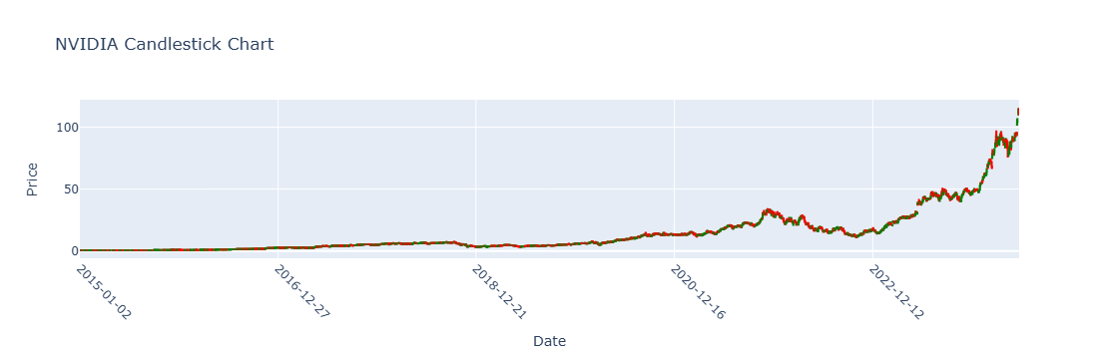
Fig. 1. Candle plot of NVIDIA stock from 2015 to 2024
The goal of the models is to predict whether the next day’s closed price would be higher or lower than today, which can be considered as a binary classification problem. The target variable can be introduced through the notion of an indicator function. The target of day i equals to 0 if the closing price of day i+1 is smaller than day i, and 1 otherwise. Note that the case where the close price of today and next day are the same is not considered separately, as it is rare in real scenarios [2]
  - Features
Feature engineering and feature selections are crucial for the performance of the model [5]. The current features all show a general increasing trend as illustrated in the candle plot; hence the information that could be given on the data is limited and not helpful. Thus, it is very important and common to use financial indicators generated from historical data as extra features for the model. The main purpose of this paper is not to give a concrete feature selection technique, hence the indicators selected are those mostly used in other papers [1] – [5], which are the following: Lag, Simple Moving Average (SMA), Moving Average Convergence and Divergenve (MACD), Relative Strength Index (RSI) , Commodity Channel Index (CCI), On-Balance Volume (OBV).
Lag captures the relative change in the stock price over a certain period, hence gives an indication of past momentum of the price. Time window used for lag is from 1 to 5. SMA gives the average of the close price over a certain period. The time windows used here are 5 and 15, since we are interested in short-term trend, larger time window will not be considered. MACD is an indicator often used as a signal for buying or selling. RSI is a momentum indicator that measures how strong recent prices are, an RSI larger than 70 is considered as a signal of the stock being overbought and oversold otherwise. CCI is also a momentum indicator that determines overbought levels. OBV is an indicator used to confirm the price trend using volume strength.
Although the selection of these indicators benefits from previous work, a verification of the importance of the feature will be given later.
  - Models
The models used are mostly basic models, yet commonly used [1] – [5], which are K-nearest Neighbor (KNN), Support Vector Machine (SVM), Logistic Regression, Random Forest, Extreme Gradient Boosting (XGBoost) and Hard Voting.
KNN is a basic supervised learning model, the training set is separated into 2 groups according to the target value they have, then for each test data, k of its closest neighbors identified, the test data would be classified according to the majority of its neighbors.
SVM is a more generalized supervised learning model that is less sensitive to outliers [5], the training data is mapped to the Euclidean Spaces according to their features, then SVM will find a best hyperplane that separates the two classes. The prediction is made through a means of a decision function.
Logistic regression is commonly used for binary classification, despite the name regression. The training data is used to minimize the loss of the sigmoid function. The data is classified according to whether sigmoid function is above or below 0.5. One property of the sigmoid function is it ranges from 0 to 1
Random Forest is a method of ensemble learning where multiple decision trees are combined to improve accuracy and prevent overfitting. Bootstrap sampling is used to generate independent subsets of the training set and feature sets, and a decision tree is trained based on the two sets. The test data is classified according to the majority of the results from the trees.
XGBoost is a more advanced and possibly more accurate model [10], unlike random forest, where many trees are constructed in parallel, XGBoost constructs each tree sequentially, each tree will try to improve the error of the previous tree, then a new prediction will be made according to the learning rate which sets weights for each tree. However, this model contains many hyperparameters and is harder to tune and computationally expensive.
Hard Voting is a simple yet effective ensemble learning model. It combines the results of different models, which can be specified. Each of them has a vote and the prediction is made based on the majority of the predictions from all models.
  - Metric
The main metric that is used to measure the performance of the models is accuracy [2] – [5], which is the percentage of correct predictions among all predictions. However, accuracy could be misleading, depending on the percentage of 1s in test set, a naïve model that only predicts 1 can achieve a quite remarkable result, hence the confusion matrix, precision and AUC score are also used.
The confusion matrix counts the number of correct and incorrect predictions for each category and hence illustrates the distribution of the prediction.
The precision is the true positive divided by predicted positive, a model with high precision can help identify the next day’s decreasing trend and hence prevent loss for investors.
The ROC curve plots true positive rate against false positive rate. AUC score is the area under the ROC curve, a good model should have an AUC close to 1, and a random guessing model should have an AUC score of 0.5, which usually act as a benchmark for the prediction of short-term trend [1].
  - Cross Validation
Parameter tuning is an essential part of finding a proper ML model [4]. However, the true parameter for a model remains unknown, but there are ways to approach this value. The method used in this paper is cross validation. The idea of cross validation is to use part of the training set as an extra test set to evaluate the model. A k-fold cross validation will first separate the training set into k disjoint subsets (folds), then one of the folds is chosen as the test set and the model is trained using the rest of the k-1 folds. This procedure is carried out on each fold, and eventually the average score of those models will be returned. In this way, the parameter of the model can be tuned by maximizing the average score.
- Result
The NVIDIA stock data set is first split into training set (80%) and test set (20%), where one is used for model training and the other is used to evaluate the performance of the models.
  - Importance of Feature Engineering and Parameter Selection
The first result demonstrated is a KNN model with no feature engineering and the parameter k is selected as the default value 5, this result will be used as a benchmark for all the other models and as expected, the accuracy of this model on the test set is very poor at around 44.94%. To emphasize the importance of feature engineering and parameter tuning, the financial indicators mentioned above are added as new features, also a 5-flod cross validation based on the average accuracy score is applied. The best k value (7) and the mean cross validation accuracy is presented Figure 2. The accuracy on the test is successfully increased by 5% to 49.46%, and the AUC score is about 0.5081, which indicates that this model is slightly better than a random guessing model.
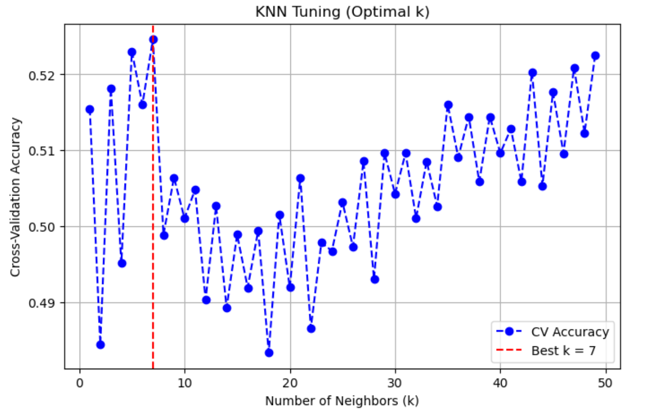
Fig. 2. 5-fold cross validation for KNN
  - Model Comparison
Apart from selecting suitable features and parameters, a suitable model is also important. The following table presents a comparison between each model based on accuracy, AUC and precision on the test set.
Table 1. Performance for different models
 | Accuracy | AUC | Precision
Logistic Regression | 45.18% | 0.4871 | 0.5172
SVM | 50.75% | 0.4982 | 0.5573
Random Forest | 46.04% | 0.5183 | 0.5345
XGBoost | 50.96% | 0.5262 | 0.5714
Only 0 Predictor | 55.67% | - | -
As anticipated, the accuracy of all the models is poor, the short-term trend of the stock price is very random and hence difficult to identify using ML models. Another reason would be the indicators are based on historical data, the features, despite being very strong financial indicators, do not guarantee to perfectly predict the future. The results suggest XGBoost model has the best performance among all models, the ROC curve of the XGBoost model is presented in Figure 3.
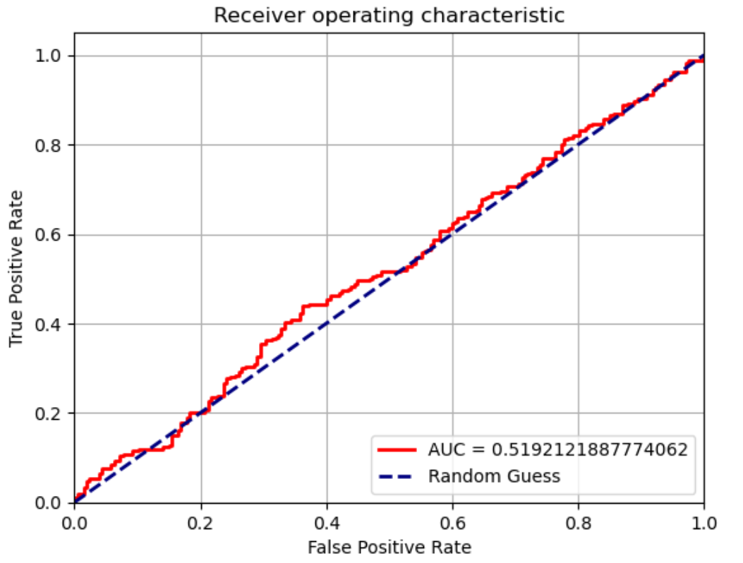
Fig. 3. The ROC curve of the XGBoost model
The ROC curve and AUC score suggest the model is doing slightly better than the random guessing model. The confusion matrix shows there are 114 true negative, 124 true positive, 136 false negative and 93 false positive. The percentage of each category predicted is approximately the same, suggesting the model is not strongly biased like the only 0 predictor.
Another problem that is not yet discussed is the sensibility of features selected. Although the features are chosen from the work of previous scholars, it is still essential to check the importance of the features via the importance plot, as shown in Figure 4.
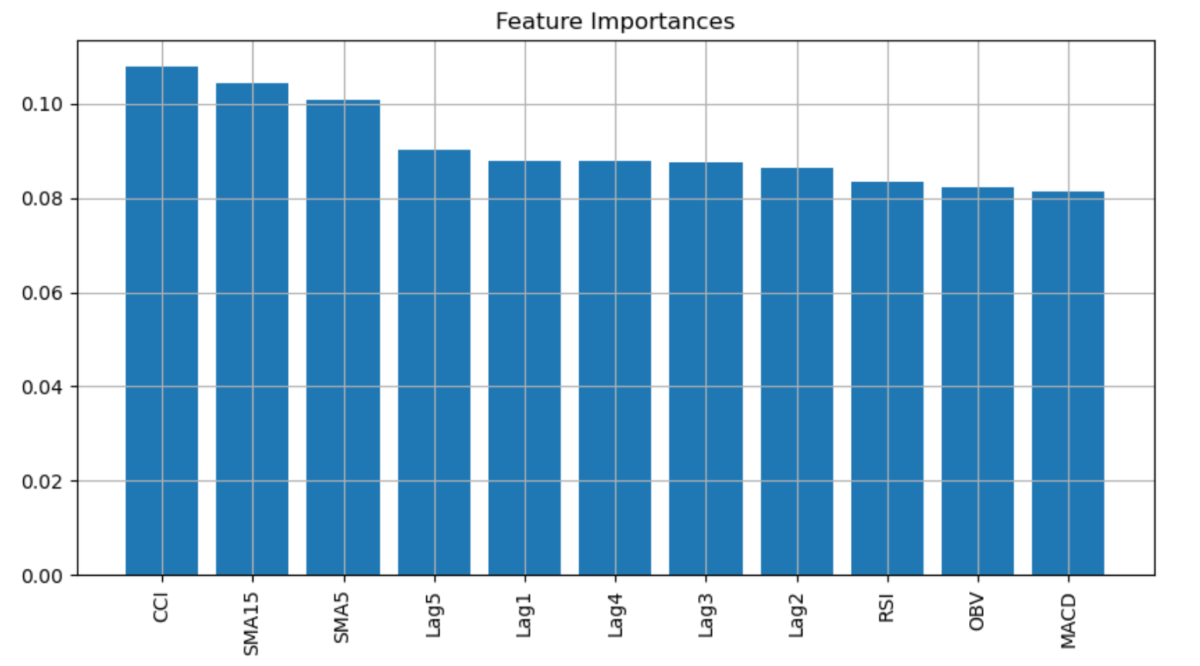
Fig. 4. The feature importance plot of XGBoost
The importance is distributed approximately even, suggest that the features used are indeed essential and sensible for the classification.
  - Optimization
The results presented above are still somehow bad, compared to the previous work discussed at the beginning. Hence two ways of improving the model are introduced.
The first thing, which is always a wise idea, is to tune the parameters with cross validation. The best model XGBoost will be tuned, but it is relatively hard to tune due to the large number of hyperparameters. Hence, only three of the parameters are used: the number of trees, the maximum depth of trees and the learning rate. The grid search method is used, where all the sensible values of the parameters are listed and then an accuracy based cross validation is applied. Table 2 illustrates the grid search result.
Table 2. Grid search for XGBoost
 | Range | Optimal
Number of estimators | 40 ~ 160 by 20 | 40
Max depth | 2 ~ 10 | 5
Learning Rate | 0.01, 0.03, 0.05,  0.07, 0.1, 0.5 | 0.01
The result using the new parameters on the test set shows an increment in accuracy to 51.82%, however, as a trade-off, the AUC score dropped to 0.4960.
Another approach is to use the Hard Voting Classifier. Voting can absorb the advantages of other models. The models chosen for the voting are the three best models so far, XGBoost, SVM and KNN. The accuracy on the test set increased to 51.61%, but the AUC score cannot be calculated, because the hard voting does not involve probabilities.
- Discussion
Table 3 compares the XGBoost model obtained above with the previous work and the differences will be analyzed.
Table 3. Comparison with previous work
 | Accuracy | AUC
Pre-tunning XGBoost | 50.96% | 0.5262
Tunned XGBoost | 51.82% | -
Hard Voting | 51.61% | -
Well-tuned SVM [4] | 57.83% | -
Wrapper SVM [5] | 67.61% | -
AdaBoost [1] | - | 0.518
The AUC score achieved in the previous XGBoost model is higher than the AdaBoost model [1], since the features used in the paper are adopted from the model and additional parameter tuning steps are added. However, the accuracy scores are still poor compared to other work. This suggests that to achieve higher accuracy, some modern techniques can be added to the model. For example, Huang introduced the wrapper feature selection technique [5], even without parameter tuning the model achieved 67.61% accuracy. There are some limitations for the methodology used, one could choose to tune more hyperparameters for the XGBoost and try to find a set of parameters that balance both accuracy and AUC scores. Moreover, it is also possible to add more advanced models like LSTM, which is a type of Recurrent Nueral Network (RNN), hence provides more powerful candidate for voting classifier.
- Conclusion
To sum up, this paper gives an overview of the short-term trend prediction problem, then emphasizes the importance of feature engineering and parameter tuning with a simple KNN example, followed by model comparison and ways of improvement through parameter tuning and ensemble learning. The model comparison suggests a possible suitable model for future stock trend prediction model, the XGBoost model. In addition, the tuned XGBoost model can achieve higher accuracy than the hard voting classifier, indicating again that parameter tuning is a crucial step for finding a good model. All the methods and models used in this paper can also be generalized to other stocks. In the future, with the help of this paper, one could develop a high frequency trading strategy based on the short-term trend prediction, but this might need a higher accuracy model

References
- Torres, L.F.: Trading with Machine Learning - Classification, https://www.kaggle.com/code/lusfernandotorres/trading-with-machine-learning-classification/notebook last accessed 2024/04/13
- Ma, Y., Mao, R., Lin, Q., Wu, P., Cambria, E.: Multi-source aggregated classification for stock price movement prediction. Information Fusion 91, 515–528 (2023)
- Yin, L., Li, B., Li, P., Zhang, R.: Research on stock trend prediction method based on optimized random forest. CAAI Trans. Intell. Technol. 8(1), 274–284 (2023).
- Kim, K.-J.: Financial time series forecasting using support vector machines. Neurocomputing 55(1–2), 307–319 (2003)
- Huang, C.-J., Yang, D.-X., Chuang, Y.-T.: Application of wrapper approach and composite classifier to the stock trend prediction. Expert Systems with Applications 34(4), 2870–2878 (2008)
- NVIDIA Corporation (NVDA) Stock |2015 – 2024|, https://www.kaggle.com/datasets/haiderrasoolqadri/nvidia-corporation-nvda-stock-2015-2024, last accessed 2025/04/13
- Altooq, K.A.A., Hasan, L.J., Kumaraswamy, S., Panigrahi, S., Tripathy, S.: Forecasting Nvidia Stock Trends: An Analytical Approach. In: 2024 International Conference on Sustainable Islamic Business and Finance (SIBF), pp. 1–6. IEEE, Bahrain (2024)
- Zhang, D., Lou, S.: The application research of neural network and BP algorithm in stock price pattern classification and prediction. Future Generation Computer Systems 115, 872–879 (2021)
- Rao, Y.V.R., Kiran, A., Chinnasamy, P., Motupalli, R., Madhuri, K.S., Kumar, D.: Analysis of Stock Market Values Using an Optimal Probability with KNN. In: 2024 International Conference on Advancements in Smart, Secure and Intelligent Computing (ASSIC), pp. 1–4. IEEE, Bhubaneswar, India (2024)
- Chen, T., Guestrin, C.: XGBoost: A Scalable Tree Boosting System. In: Proceedings of the 22nd ACM SIGKDD International Conference on Knowledge Discovery and Data Mining (KDD ’16), pp. 785–794. ACM, New York, NY, USA (2016)

(Open Access Text)

Springer Nature will add OpenAccess standard text here during typesetting. Springer Nature will add OpenAccess standard text here during typesetting Springer Nature will add OpenAccess standard text here during typesetting. Springer Nature will add OpenAccess standard text here during typesetting. Springer Nature will add OpenAccess standard text here during typesetting. Springer Nature will add OpenAccess standard text here during typesetting.
Springer Nature will add OpenAccess standard text here during typesetting. Springer Nature will add OpenAccess standard text here during typesetting. Springer Nature will add OpenAccess standard text here during typesetting. Springer Nature will add OpenAccess standard text here during typesetting. Springer Nature will add OpenAccess standard text here during typesetting.
Springer Nature will add OpenAccess standard text here during typesetting.

